Reports output

Microsoft Dynamics 365 Finance & Operations (M365)

AP Group :
Team leader: Amira Allam
Group members: Mohamed khairy
Sohila Ashraf
Maria Bassem

Vendor Statement Explanation:

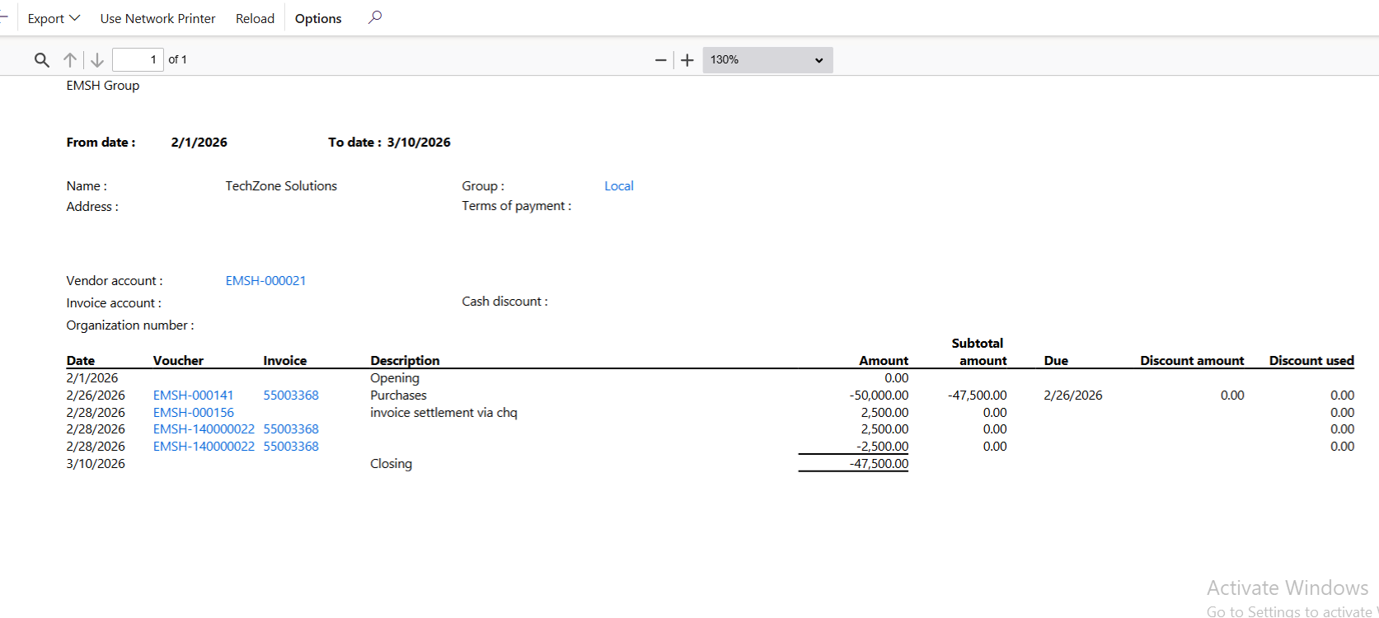 1. Report Header Information
At the top of the report you can see general information about the vendor and the reporting period.
Company: EMSH Group
From date: 2/1/2026
To date: 3/10/2026
This means the report shows all vendor transactions between these two dates.
Vendor Information
- Name: TechZone Solutions
- Vendor account: EMSH-000021
- Group: Local

Vendor Invoice
2/26/2026
Voucher: EMSH-000141
Invoice: 55003368
Description: Purchases
Amount: -50,000
This indicates that:
- The company received goods/services from the vendor
- An invoice of 50,000 EGP was recorded
- The company owes the vendor this amount
Negative values usually represent vendor liability.
Running subtotal: -47,500

Payment Transactions
2/28/2026
Voucher: EMSH-140000022
Description: Invoice settlement via cheque
There are two entries of 2,500.
These represent payments made to the vendor to settle part of the invoice.
Payment effect:
- Reduces the vendor balance.

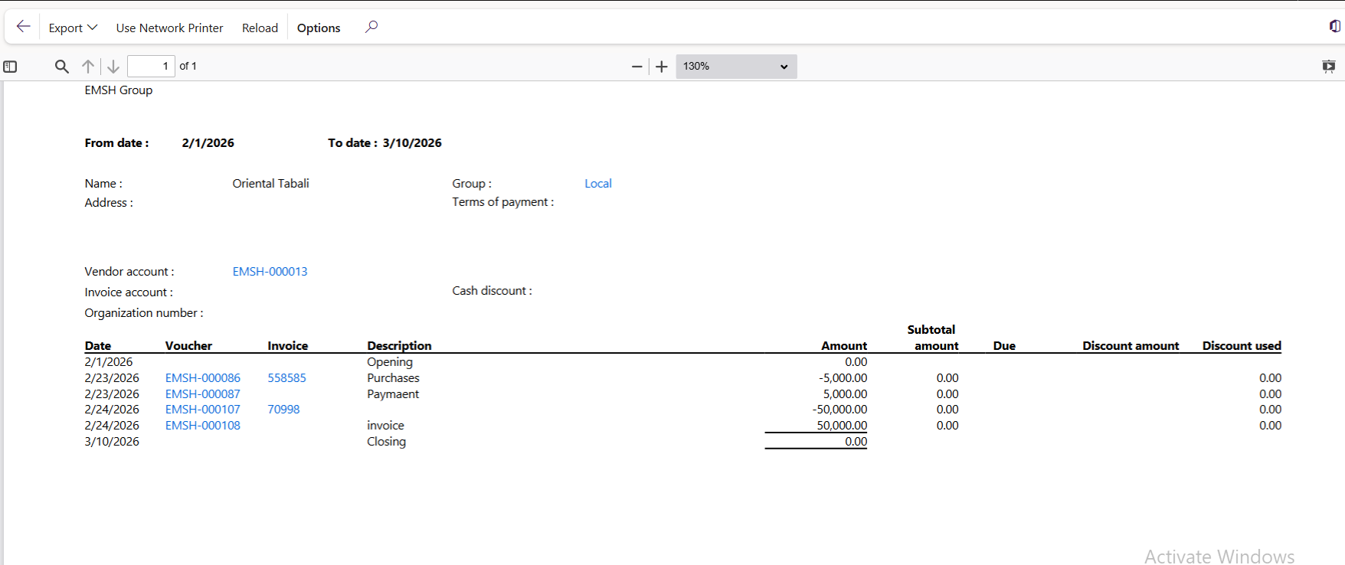

1. Report Header (General Information)
Company: EMSH Group
From date: 2/1/2026
To date: 3/10/2026
This means the report shows all transactions with this vendor between these dates.
Vendor Details
- Vendor Name: Oriental Tabali
- Vendor Account: EMSH-000013
- Vendor Group: Local

Vendor Invoice (Purchase)
2/23/2026
Voucher: EMSH-000086
Invoice: 558585
Description: Purchases
Amount: -5,000
Meaning:
- Your company purchased goods/services from the vendor
- A vendor invoice of 5,000 EGP was recorded
- The company owes the vendor 5,000

Vendor Payment
2/23/2026
Voucher: EMSH-000087
Description: Payment
Amount: +5,000
Meaning:
- The company paid the vendor 5,000
- This cleared the previous invoice
Balance returns to 0.

Second Vendor Invoice
2/24/2026
Voucher: EMSH-000107
Invoice: 70998
Amount: -50,000
Meaning:
- A new vendor invoice of 50,000 was recorded.
- The company now owes the vendor 50,000.

Invoice Settlement / Adjustment
2/24/2026
Voucher: EMSH-000108
Amount: +50,000
This entry settled or reversed the previous invoice.
Possible reasons:
- Payment was recorded
- Invoice was cancelled
- Credit note or adjustment was applied
After this transaction, the balance becomes 0 again.

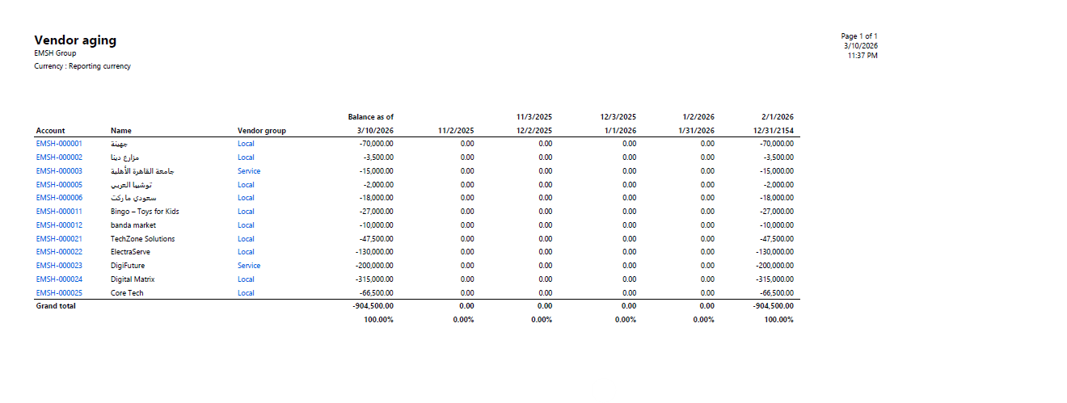
Vendor Aging Report Explanation
Purpose of the Report
The Vendor Aging Report displays all outstanding balances owed to vendors and categorizes them based on the due date period.
It helps the finance department:
- Track unpaid vendor invoices
- Monitor overdue payments
- Plan cash flow for vendor payments

Vendor Information
The first columns show vendor identification details:
- Account
The unique vendor ID in the system (Example: EMSH-000001).
- Name
The name of the vendor or supplier.
- Vendor group
The category assigned to the vendor such as:
  - Local
  - Service
This helps the company organize vendors by type.

Balance as of Date
Balance as of 31/10/2026
This column shows the total outstanding balance owed to each vendor as of the report date.
Example:
- Vendor balance -70,000 means the company owes 70,000 to that vendor.
In Accounts Payable reports, balances often appear negative because they represent liabilities.

Aging Period Columns
The columns to the right divide the outstanding balances into time periods based on invoice due dates.
Examples of periods shown:
- 11/2/2025
- 12/2/2025
- 1/2/2026
- 2/1/2026
These columns indicate when the payment is due or overdue.
If a value appears in one of these columns, it means the invoice falls within that aging period.
In your screenshot, most values are 0.00, meaning the balances are grouped in the final aging category.

Vendor Balance Distribution
Each row shows:
- The vendor
- Their total outstanding amount
- Which aging period the amount belongs to
Example:
Vendor TechZone Solutions
Outstanding balance: 47,500
This tells the finance team how much must be paid to that vendor.

Grand Total
At the bottom of the report:
Grand total: -904,500
This represents the total amount the company owes to all vendors combined.
The percentages below show the distribution of the balance across aging periods.

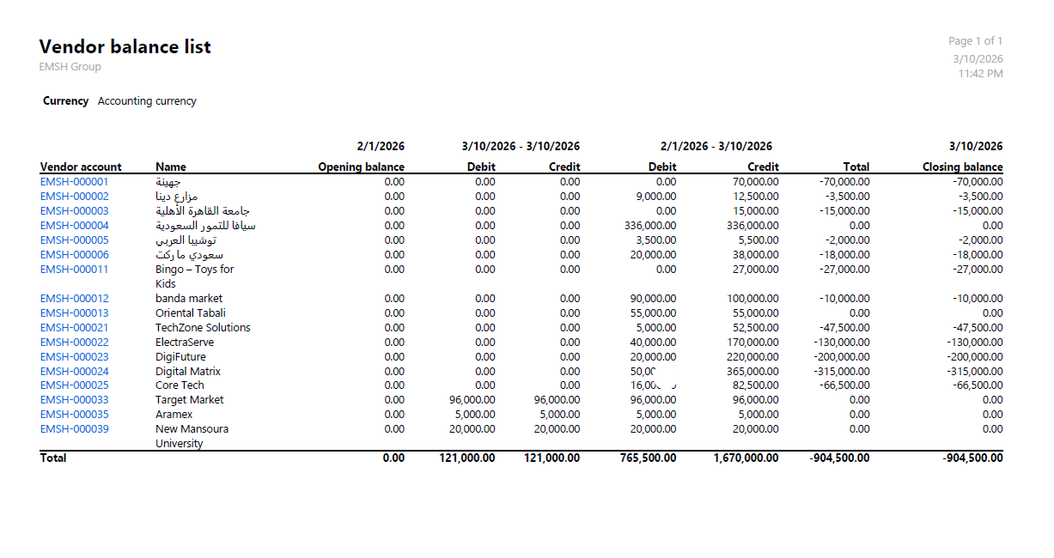Vendor Balance List Report Explanation
Purpose of the Report
The Vendor Balance List report displays the financial transactions and balances for each vendor within a selected time period.
It helps the finance team to:
- Monitor vendor account activity
- Review payments and invoices
- Check opening and closing balances
- Verify accounts payable records

Vendor Identification
The first columns show vendor details:
- Vendor Account
The unique vendor ID in the system (Example: EMSH-000001).
- Name
The name of the vendor or supplier.
These columns help identify each supplier in the report.

Opening Balance
Opening Balance (2/1/2026)
This shows the vendor balance at the beginning of the reporting period.
In this report:
- Most vendors have 0.00 opening balance, meaning there were no outstanding balances before the selected period.

Debit and Credit Transactions
The report then shows financial transactions during the selected period.
Debit
Represents transactions that increase the payable amount to the vendor.
Examples:
- Vendor invoices
- Purchase transactions
Credit
Represents transactions that reduce the payable amount.
Examples:
- Vendor payments
- Credit notes

Total Balance
The Total column shows the net balance for each vendor after calculating:
Debit − Credit
If the result is negative, it means:
➡ The company owes money to the vendor.
Example:
- Vendor Digital Matrix
Balance: -315,000
This means the company still owes 315,000 to that vendor.

Closing Balance
The Closing Balance (3/10/2026) represents the final balance for each vendor at the end of the reporting period.
It is calculated as:
Opening Balance + Debit − Credit
This value shows the current payable amount to each vendor.

Total Summary
At the bottom of the report:
- Total Debit: 762,500
- Total Credit: 1,670,000
- Total Vendor Balance: -904,500
This means the company owes vendors a total of 904,500.

